GLOBAL EDUCATION CLUSTER STRATEGY PACKAGE
RESPONSE FRAMEWORK DESIGN TOOL
The heart of the Strategy and the blueprint for the entire response is the Response Framework. The Response Framework outlines the Cluster’s objectives and prioritized activities with accompanying indicators and contextualized standards and costing. It will serve as a ‘menu’ around which partners, based on their comparative strengths and experiences, can design their programs and projects to ensure a harmonized response. For more details on Response Framework and definitions, refer to the full Guide. The Education Cluster Strategy Template contains a Response Framework section, which will help you capture all components of your framework, as shown in the image below:
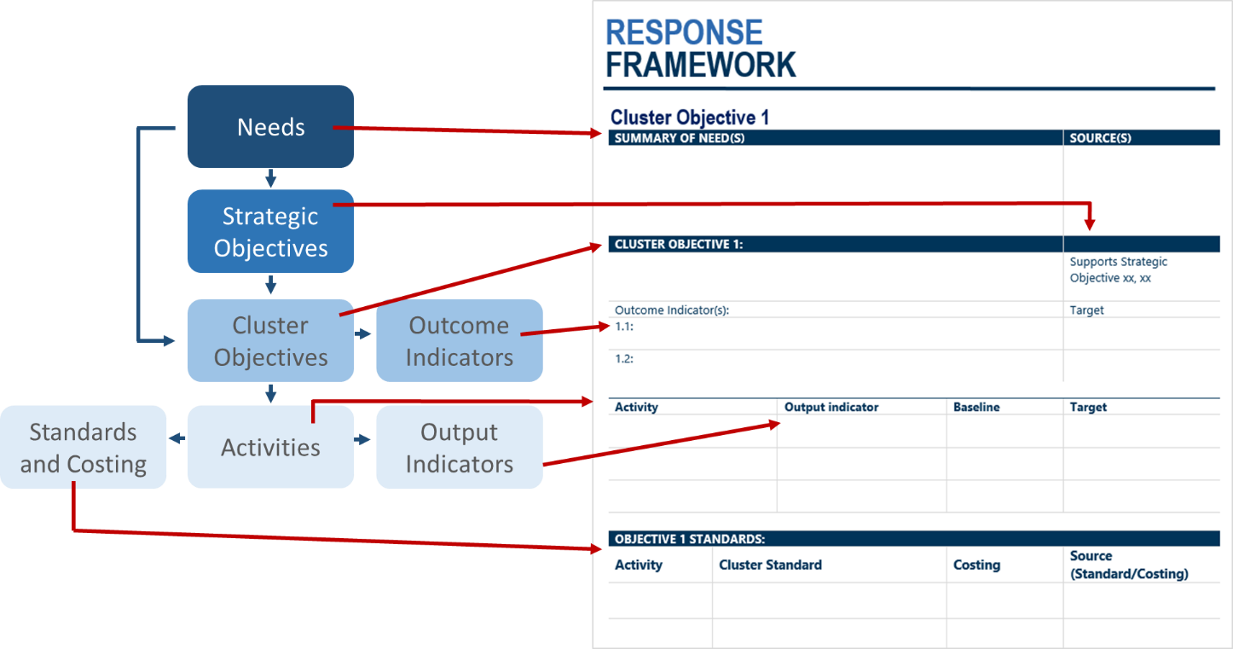
This Response Framework Design Tool is intended to help you when drafting/revising your Response Framework, guiding the response planning process. It provides examples and a guiding structure so that you do not have to start from scratch. However, please remember that every context is different: your work should be driven by identified needs and your response should reflect the complexities of the emergency situation. The aim of this tool is to help you analyze, define and frame the response; it should not be viewed as prescriptive or restrictive.
A note on process: When developing the initial draft of the Response Framework, consider these tips:
- Gather relevant documents: Education Cluster Needs Overview, HNO/HRP (if available), Secondary Data Review reports, Needs Assessment reports, past Cluster Strategy and/or HRPs from your country as well as other contexts, etc.
- Work with a small group for the initial draft such as the Cluster Team and/or with a sub-group of the Strategy Task Team
- Consider mapping out a diagram (such as the example on page 4 below); you may want to use a whiteboard, Post-It Notes or VIP cards so you can move around elements of the Response Framework to find the most logical flow. You can create an electronic version of your diagram using the modifiable version of the one below found in the Education Cluster Strategy Template_Graphics file in the Strategy Package.
- Take photos to capture the process and especially the end result.
- Once the broad elements of your response are mapped out in your diagram, move on to crafting the specific wording of objectives and activities and the details of the indicators, standards and costing within the Response Framework Table (see numbered guidance below).

- Review needs and Strategic Objectives: Review the specific needs of the affected population for your context (refer to your Education Cluster Needs Overview) as well as any drafted or finalized inter-sector (i.e. HRP) Strategic Objectives. Note: if inter-sector Strategic Objectives are not yet developed, proceed drafting your Response Framework anyway, leaving time and flexibility in the process to make adjustments once they are confirmed. Most Strategic Objectives will fall into the categories indicated below: Life-saving, Protection, Access to basic services and Resilience.
- Determine the geographic and operational scope/priorities of the response: Based on these needs, determine the geographic and operational scope/priorities for the response. Record the geographic priorities in the Response Framework section of the Education Cluster Strategy Template. For more information on this step, see Section 3.1. in the full Guide.
- Draft the Education Cluster Objectives: Based on identified education-specific needs, the inter-sector Strategic Objectives and geographic and operational priorities, draft the Education Cluster Objectives. Experience has shown that Education Cluster Objectives often fall into the following categories:
  - Safe, protective and quality learning spaces
  - Life-saving messages and psychosocial support
  - Alternative and continuous education
  - Resilient systems, communities, schools and children
Some Response Frameworks will use objectives from all four of these categories, others may need only two or three; this will depend on your context and the identified needs. The tables below provide some country-specific examples of language for each of these Objective categories. Feel free to use these as a starting point and modify for your context. Try to make your Objectives as clear, concise and precise as possible.
HINT: if you get stuck or are struggling to draft the Cluster Objectives, ask yourselves: “What changes do we plan to make?” and “How?”. You may also want to try moving on to the next step and draft activities first; then come back to group activities into Cluster Objectives. Some people find this ‘bottom-up’ approach to be easier/more intuitive than the ‘top-down’ approach of starting with objectives. However, take care: listing activities because it is what has been done before, is what partners are already doing or is what donors are requesting will likely result in a weak Response Framework. The key thing to remember: everything must be based on identified needs.
- Draft the activities: Based on identified education-specific needs, determine the appropriate response interventions/activities that support each Cluster Objective. Use the proposed activities below as a starting point and add/remove activities and adapt the language as needed.
- Draft the indicators: Next, determine how each Cluster Objective and activity will be measured by drafting indicators. The tables below provide specific and concrete examples of outcome and output indicators for each suggested Cluster Objective and activity, respectively. You may also want to consult the humanitarian indicator registry. Remember:
  - Outcome indicators: Measure the intended or achieved short- and medium-term effects of an activity’s outputs and the progress against the stated Cluster Objectives. Typically, the outputs of several interventions will contribute to one outcome. Outcome indicators therefore need to be designed so they can measure the collective change that happens as the result of several outputs.
  - Output indicators: Measure the delivery of goods and services to a targeted population. Activities may have multiple output indicators, depending on what you will want to measure/monitor. Typically, one of these outputs will be material based (e.g. classrooms, kits, etc.) and the other will be person based (e.g. children benefiting from..., teachers trained in…, etc.).
- Draft activity standards and costing: Each activity will need to be contextually defined through standardization and costing. Using the INEE Minimum Standards as a starting point, contextualized standards will help ensure all partners understand the minimum level of service delivery quality for each activity. Providing a guiding range of cost per activity and cost per beneficiary for each activity will help partners when developing harmonized project proposals. It will also help when calculating the Cluster’s overall financial requirements. The tables below propose some questions and issues to consider to help you; however, it is likely that the bulk of the information for determining standards and costing will need to come through consultations with partners (see step #6).
- Consult with stakeholders: Once the initial draft of the Response Framework is prepared, consult with your partners and relevant stakeholders to a) ensure the relevancy and appropriateness of the language of the drafted objectives and activities, b) receive detailed contextual knowledge and consensus around activity standards and costing. These consultations will not only improve the quality and relevance of the Response Framework, but can also play a significant role in ensuring buy-in from key actors. HINT: As determining indicator language can be more technical, you may want to remove indicators from your general consultations and share in a more targeted way with technical experts. For example, for WASH-related indicators, consult with the WASH Cluster. You could also ask Strategy Task Team members to share with their organization’s Monitoring and Evaluation Specialists if appropriate.
The Strategy Package has a range of further resources to support the Response Framework consultation process, which is a critical part of strategy development:
  - See the full Guide Sections 3.3 and 3.4. to read more about Response Framework consultations
  - Stakeholder Survey of Response Framework Template
  - Response Framework Workshop: Checklist, Agenda, PowerPoint Presentation Template and Handout Templates
REMEMBER:
- The diagram and tables below are NOT intended to be an exhaustive or prescriptive list; you will most likely have adaptations to make to ensure the Framework is needs-based and contextualized
- Do NOT copy and paste the entire list simply because it sounds good or important! Consider the specific needs of your context and the most strategic and effective way to meet them.
- Be sure to contextualize the language of the objectives, activities and indicators you use; using language from the HRP or other relevant national documents or plans can be strategic (for more guidance on Alignment issues see the Alignment Matrix).

EXAMPLE EDUCATION CLUSTER RESPONSE FRAMEWORK DIAGRAM
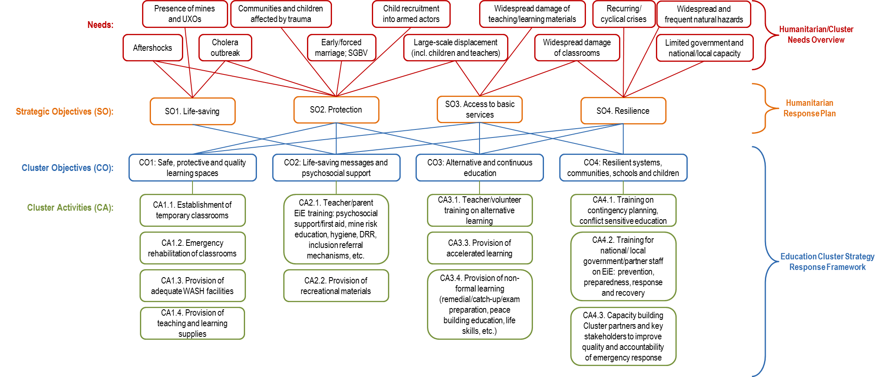

Cluster Objective 1: Safe, protective and quality learning spaces
This Cluster Objective focuses on the safe and protective nature of the physical space of the classroom as well as getting school-aged children and youth into those spaces for quality learning. It lends itself well to supporting inter-sectoral Strategic Objectives related to: Protection and Access to basic services.
Country | Examples of Cluster Objective 1 | Source
Yemen | All crisis affected girls and boys (3-18) have equitable access to safe, inclusive and equipped learning spaces | Yemen Education Cluster Strategy 2016-2017
South Sudan | Crisis-affected girls and boys (3-18) have access to safe, healing and inclusive learning spaces | South Sudan HRP 2017
Nepal | Girls and boys access early childhood, primary and secondary education in safe and protective learning spaces | Nepal Education Cluster Strategy 2015
Liberia | All school-going children have access to safe, sufficient and appropriate learning spaces inclusive of adequate WASH facilities so as to safeguard student-health and contribute to improved learning outcomes | Liberia Education Cluster Strategic Recovery Plan 2015
Suggested outcome indicator(s):
  - # of (and/or % of targeted) crisis affected [children and youth/girls and boys 3-18] with access to repaired and established safe, protective and quality learning spaces with adequate WASH facilities
  - # of (and/or % of targeted) crisis affected [children and youth/girls and boys 3-18] provided with adequate school supplies

# | Activity | Suggested output indicators | Standards and costing: questions to consider
CA1.1. | Establishment of temporary classrooms | # of temporary classrooms established | - Size of temporary classroom (square meters as well as # of learners per)  - Materials to be used/prohibited for walls and roof (tent/tarpaulins, wood, metal, brick, concrete, etc.)  - Timeframe and phases (e.g. tents within first XX months then semi-permanent)  - Unit costs for various models/materials  - WASH standards (see below)  - Protection standards: fencing, first aid kit, etc.
 |  | # of children with access to temporary classrooms with adequate WASH facilities
CA1.2. | Emergency rehabilitation of classrooms | # of classrooms repaired | - What constitutes ‘emergency rehabilitation’: timeframe (e.g. within XX number of days of incident), cost (less than $500), type of repair, etc.  - WASH standards (see below); Protection standards: fencing, first aid kit, etc.
 |  | # of children with access to repaired classrooms with adequate WASH facilities
CA1.3. | Provision of adequate WASH facilities | # of latrines established | - Should this activity be incorporated into the standard for CA1.1 and CA1.2 as a sort of standardized ‘package’? Or a separate activity and monitored individually?  - How many girls per latrine? Boys? Type of latrine/materials to be used? Unit costs?  - How many litres of water per learner per day for drinking and handwashing?
 |  | # of handwashing stations established and provided with adequate water
CA1.4. | Provision of teaching and learning supplies | # of learning supply kits distributed | - Minimum contents/unit costs for learning supply kits (e.g. carrier bag,/backpack, # and size of exercise/note books and/or XX pages per learner per school year, ruler, pens/pencils, etc.)  - Minimum contents/costs for teaching kit (e.g. logbook/notebooks and size/page count, pen, etc.)  - NOTE: As learning and teaching supply kits will most likely vary between school levels, each type of kit will need its own standards
 |  | # of learners benefitting from distributed learning supply kits
 |  | # of teacher kits distributed
 |  | # of teachers/volunteers benefitting from distributed teacher kits

Cluster Objective 2: Life-saving messages and psychosocial support
This Cluster Objective focuses on reducing life-threating and psychosocial risks to children and youth through the life-saving messaging, psychosocial support and referral mechanisms that can take place within the learning environment through appropriately trained education personnel and parents/caregivers. It lends itself well to supporting inter-sectoral Strategic Objectives related to Life-saving, Protection and Resilience.
Country | Examples of Cluster Objective 2 | Source
Yemen | Risks to all crisis affected girls and boys (3-18) are reduced through the improved ability to cope with negative psychosocial effects and to limit the physical danger presented by conflict | Yemen Education Cluster Strategy 2016-2017
South Sudan | Risks to crisis-affected girls and boys (3-18) are reduced | South Sudan HRP 2017
Nepal | Through quality age-appropriate learning, girls and boys acquire psychosocial, lifesaving and disaster preparedness skills to restore wellbeing and build the resilience of children and their communities | Nepal Education Cluster Strategy 2015
Liberia | School administrations, teachers and PTAs are able to adequately react to the health needs of children and to ensure a safe school environment including access to psychosocial support in a healthy school environment | Liberia Education Cluster Strategic Recovery Plan 2015

Suggested outcome indicator(s):
  - # of (and/or % of targeted) teachers (formal and volunteers) trained in education in emergencies

  - # of (and/or % of targeted) crisis affected [children and youth/girls and boys 3-18] with access to teachers trained in education in emergencies

# | Activity | Suggested output indicators | Standards and costing: questions to consider
CA2.1. | Teacher/parent EiE training: psychosocial support/first aid, mine risk education, hygiene, DRR, inclusion, referral mechanisms, etc. | # of teachers (formal and volunteers) trained in education in emergencies | - If the ‘package approach’ is used, which modules will be included? Mandatory? Optional?  - Duration of each training and/or module (e.g. minimum of XX hours) for teacher training as well as duration of [PTA] training, if these differ.  - Will there be a standardized curriculum and training guide for the content or will partners be able to use own materials?  - Is there any inter-sectoral collaboration that should be included as a standard part of the activity? E.g. liaison with child protection actors regarding referral mechanisms? Coordination with health actors to provide trainings on particular modules?  - Unit costs
 |  | # of learners benefitting from a teacher trained in education in emergencies
 |  | # of [Parent Teacher Associations] trained in education in emergencies
 |  | # of learners accessing schools with a [Parent Teacher Association] trained in education in emergencies
CA2.2. | Provision of recreational materials | # of recreational kits distributed | - Size of recreational kit (e.g. should serve XX learners)  - Minimum contents/unit costs for recreational kit (e.g. # of footballs, ball pump, skipping rope, Frisbee, puzzles, games, etc.)
 |  | # of learners benefitting from distributed recreational kits

Cluster Objective 3: Alternative and continuous education
This Cluster Objective recognizes that formal learning may be unavailable/inaccessible during an emergency and focuses on providing alternative options to ensure that education is continuous and any lost learning can be quickly made up. In this aspect is lends itself well to supporting inter-sectoral Strategic Objectives on Access to basic services and Resilience. Depending on contextual needs, this Cluster Objective can also have a strong Protection element given a potential focus on providing alternative learning opportunities in order to reduce risks of recruitment into armed actors, child labor and exploitation, particularly for youth.
Country | Examples of Cluster Objective 3 | Source
Yemen | When formal classes are unavailable, learning time has been lost, or learning spaces are inaccessible, crisis affected girls and boys (3-18) have the ability to attend flexible, alternative learning opportunities. | Yemen Education Cluster Strategy 2016-2017
South Sudan | Enable conflict-affected children and young people to pursue healthy, productive lives through age and gender appropriate alternatives to recruitment, child labor and exploitation | South Sudan HRP 2015
Liberia | Children in every community have access to continuous complementary learning opportunities which are flexible and sustainable during emergencies and students are provided the opportunity to make up lost learning through supplemental opportunities organized at the school and community level | Liberia Education Cluster Strategic Recovery Plan 2015

Suggested outcome indicator(s):
  - # of (and/or % of targeted) teachers (formal and volunteers) trained in alternative learning

  - # of (and/or % of targeted) crisis affected [children and youth/girls and boys 3-18] accessing alternative learning

# | Activity | Suggested output indicators | Standards and costing: questions to consider
CA3.1. | Teacher/volunteer training on formal alternative learning | # of teachers (formal and volunteers) trained in alternative learning activities | - How will alternative learning be defined in your context; what are the different types of alternative learning that will be considered? (e.g. radio classes, self-learning activities, community program classes, vocational training, etc.)  - Duration of each training and/or module (e.g. minimum of XX hours)  - Will there be a standardized curriculum for the content or will partners be able to use own materials  - Unit costs
 |  | # of learners with access to a teacher trained in the provision of alternative learning
CA3.2. | Provision of accelerated learning | # of teachers (formal and volunteers) trained in accelerated learning | - Duration of each training and/or module (e.g. minimum of XX hours)  - Will there be a standardized curriculum for the content or will partners be able to use own materials  - Unit costs
 |  | # of learners accessing accelerated learning
CA3.3. | Provision of non-formal learning | # of teachers (formal and volunteers) trained in non-formal learning | - How will non-formal learning be defined in your context; what are the different types of non-formal learning that will be considered? (e.g. literacy, numeracy, life skills, peace building, , non-formal vocational training, etc.)  - Unit costs
 |  | # of learners accessing non-formal learning

Cluster Objective 4: Resilient systems, communities, schools and children
This Cluster Objective focuses on building the capacity of the education system – including the Cluster or other coordination bodies – to better prevent, prepare for and withstand shocks. It is an objective that might be most relevant in protracted crises or areas that are at risk of natural hazards. Given the focus on ensuring the continuity of educational provision as well as the systems-strengthening components, this objective supports inter-sectoral objectives relating to Access to basic services and Resilience.
Country | Examples of Cluster Objective 4 | Source
Syria | Strengthen the capacity of the education system and communities to deliver a timely, coordinated and evidence-based education response | Syria HRP 2017
Somalia | Strengthened capacity to deliver effective and coordinated education in emergencies preparedness and response within the education system | Somalia HRP 2017
occupied Palestinian territories | All education stakeholders including parents, communities and children are better able to cope and respond to disaster and emergencies through DRR preparedness and psychosocial services, particularly in areas at risk of education-related violations and natural disasters. | oPt HRP 2017

Suggested outcome indicator(s):
  - # of (and/or % of targeted) education stakeholders (government and partners) trained on education in emergencies
  - # of (and/or % of targeted) Cluster Partners benefitting from capacity building to improve quality and accountability of humanitarian response

# | Activity | Suggested output indicators | Standards and costing: questions to consider
CA4.1. | Training on contingency planning, conflict sensitive education | # of education actors trained on conflict sensitive education | - Duration of each training and/or modules (e.g. minimum of XX hours)  - Will there be a standardized curriculum and training guide for the content or will partners be able to use own materials?  - Unit cost
 |  | # of [ADMIN LEVEL] with updated Contingency Plan in place | - Is there a standard format for Contingency Plans that will be developed and required?  - How will communities be engaged to support the identification of hazards and risks and contribute to planning?
CA4.2. | Training for education actors (national/local government/partner staff) on EiE: prevention, preparedness, response & recovery | # of education actors trained on policy, planning, data collection, sector coordination and INEE MS | - If the ‘package approach’ is used, which modules will be included? Mandatory? Optional?  - Duration of each training and/or module (e.g. minimum of XX hours), noting any differences for different groups of actors e.g. Cluster partner organizations or local government actors.  - Standardized curriculum and training guide for the content or will partners use own materials?  - Unit cost
 |  | #/% of Cluster partners who are national/local organisations | - What defines a Cluster partner? Attendance at Cluster meetings? Reporting to Education Cluster Monitoring Tool? Other?
 |  | # of government education planning or policy documents (local/national) that include education in emergencies issues | - Are there any particular government processes and policies that the Cluster plans to engage with?
CA4.3. | Capacity building Education Cluster partners and key stakeholders to improve quality and accountability of emergency response | # of Education Cluster partners trained to improve crisis-sensitive data collection, analysis and use | - Duration of each training and/or module (e.g. minimum of XX hours)  - Will there be a standardized curriculum and training guide? What data collection tools should the training cover?  - Unit cost
 |  | #/% of Education Cluster partners with community feedback mechanisms in place | - Are there any key documents that partners should reference in their Feedback Mechanisms? e.g. INEE Minimum Standards or Core Humanitarian Standard
 |  | # of Education Cluster partners participating in cross-agency capacity development | - What types of capacity development actions are acceptable? E.g. Coaching, mentoring, one-off trainings, e-learning etc.

This will go a long way in helping to ensure alignment between Cluster and organizational activities and indicators, thus increasing harmonization and decreasing the need for parallel reporting structures.
A modifiable version of this diagram is contained in the Education Cluster Strategy Template_Graphics file in the Strategy Package.
While it is typically acceptable to group as ‘children’ within the Response Framework and HRP, these indicators should disaggregated by sex and age-group when collecting/monitoring
Kit contents for both teaching and learning kits will most likely vary between school levels; therefore, you may want to disaggregate these into multiple indicators (e.g. early childhood/pre-primary, primary, junior secondary, senior secondary)
As stated here, this training is seen as a single, ‘packaged’ EiE training; it will be up to you and your Cluster to set a a standard that specifies the selected modules (psychosocial support/first aid, mine risk education, hygiene, DRR, inclusion, referral mechanisms, etc.), timeframe, etc. This approach uses a single output indicator tracking only the # of teachers who have completed the entire training package. Alternatively, you may wish to monitor each module separately with an individual output indicator for each (e.g. # of teachers trained in psychosocial support/first aid, # of teachers trained in mine risk education, etc.). If you choose to use multiple output indicators, you may want to consider using one of these (e.g. # of teachers trained in psychosocial support) as the outcome indicator.
Change to School Management Committees, Community Education Council, etc. to fit your context. Also decide if you prefer the unit of measurement to be the association/ committee/council itself or the # of members of those groups (or have two indicators and track both).

